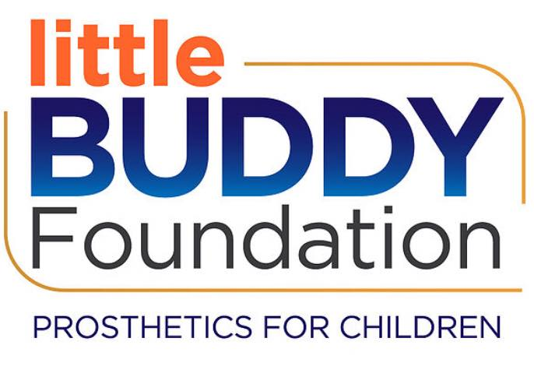
LITTLE BUDDY FOUNDATION
RECIPIENT APPLICATION

Child’s Information
Name: _____________________________________________________________________
Address: __________________________________________________________________
Date of Birth: __________________________
Gender: _________________________________
Limb Difference: _____________________________________________________________
Date of Loss of Limb(s): __________________________________
Circumstances surrounding loss of limbs: _____________________________________________________
_________________________________________________________________________________________________________
_________________________________________________________________________________________________________
_________________________________________________________________________________________________________
_________________________________________________________________________________________________________
Fun Information
Child’s Favorite Activity: __________________________________________________________________________
Child’s Favorite Color: _____________________________________________________________________________
Child’s Favorite Animal: ___________________________________________________________________________
Insurance
Is Child covered by Insurance? Yes __________ No __________
Whose Insurance? _____________________________________________
Name of Insurance Provider: ________________________________________________________
Does Medicaid apply? Yes __________ No __________ Unknown ___________
Type of Prosthetic Needed: ____________________________________________
Amount of Funds Being Requested: $_______________________________
List of other financial resources available to the child’s family (i.e. other grants, sponsorships, fundraisers, etc.): _________________________________________________________________
_________________________________________________________________________________________________________
_________________________________________________________________________________________________________
Medical Providers
Name of Child’s Physician: _______________________________________________________________________
Name of Child’s Medical Facility: ________________________________________________________________
Address of Child’s Medical Facility: _____________________________________________________________
Name of Child’s Prosthetist: ______________________________________________________________________
Address of Child’s Prosthetist: ___________________________________________________________________
Name of Person completing this Application: _________________________________________________
Address: _____________________________________________________________________________________________
Phone Number: ___________________________________________________
Relationship to Child: _____________________________________________________
Grant Awarding Criteria:
- Proximity to North Dakota
- Age of Recipient
- Other Financial Resources Available to Recipient and Family
- Little Buddy Foundation’s Ability to Help

Grant Process:
Application Submitted Little Buddy Foundation Board Review Contacts made between Little Buddy Foundation, Our Team, Child, and Child’s Supporters Determination of Grant Capability
Please email completed applications to littlebuddyfoundation@gmail.com
Learn more at: littlebuddyfoundation.org

